DocNo: 001.D.1:1

Bug Tracking
Software Architecture Document
Version 2.0

By:
Twister Group
2003-07

Group Member:
Bob
Jalin
Mario
Roger
Minerva

Document Language:
English

Revision History
Date | Version | Description | Author
<13/08/2003> | <1.0> | 1st edition | Mario and us all
<23/08/2003> | <2.0> | Final edition(Revised) | <Minerva>
Final date | <x.x> | <details> | <name>
Key Word
Bug
BTS
Architecture
Design
Digest
This document is to describe the software architecture of BTS. It is the guideline of our BTS developing. In this document , we describe the detailed design idea and reader can have a clear picture with referring to the rational rose design model.

1Introduction 4
1.1Purpose 4
1.2Scope 4
1.3References 4
2Architectural Representation 4
3Architectural Goals and Constraints 5
4Use-Case View 5
4.1Architecturally-Significant Use Cases 6
5Logical View 7
5.1Overview 7
5.2Design Mechanisms 8
5.3Security Mechanism: 14
5.4Architecturally-Significant Use Case Realization: 17
5.5Architecturally-Significant Model Elements: 17
5.6Architecturally-Significant classes: 18
6Process View 19
7Deployment View 19
8Implementation View 19
9Size and Performance 20
10Systems Size 20

1Introduction

1.1Purpose
This document provides a comprehensive architectural overview of the Bug Tracking System, using a number of different architectural views to depict different aspects of the system. It is intended to capture and convey the significant architectural decisions, which have been made on the system.

1.2Scope
This document should be an overview of the architecture and how it should be modeled. Decisions in this document affect how the system is modeled.

1.3References
- J2EE Best Practices and Design Strategies. Published By SUN, Written by Deepak Alur, John Crupi and Dan Malks.
- The Unified Software Development Process. Written by Ivar Jacobson, Grandy Booch, James Rumbaugh.
- UseCaseSpecification_Report Bugs.doc
- UseCaseSpecification_Edit Bugs.doc
- UseCaseSpecification_Creat Project.doc
- SystemRequirementsDocument20.doc
- BTS rose design model.

2Architectural Representation
The architecture of the application is represented following the recommendations of the Rational Unified Process and the Rational Architecture Practice guidelines. And this document presents the architectural as a series of views:
- Use Case View
- Logical View
- Process View
- Implement View
- Deploy View
The Logical View and the Component View also include packages that represent Java language and J2EE framework elements. Collectively the above models and packages form a complete UML specification of the system.

3Architectural Goals and Constraints
There are some key requirements and system constraints that have a significant bearing on the architecture. They are:
- Provide an on-line platform for developers to track the bugs in their product.
- The system must ensure complete protection of data from unauthorized access. All accesses are subject to user identification and password control.
- The system will be implemented as a web browser-server system. The users access the system from Internet explorer in their on PCs and the server portion must operate on the Windows Server in the company intranet.
- The system architect must comply with J2EE Tier-architect.
- All performance and loading requirements, as stipulated in the Vision Document and the Supplementary Specification, must be taken into consideration as the architecture is being developed.
- The BTS system must integrate with an external staff information system.

4Use-Case View
A description of the use-case view of the software architecture. The Use Case View is important input to the selection of the set of scenarios and/or use cases that are the focus of an iteration. The functionality of BTS is captured in the use-case diagram below:
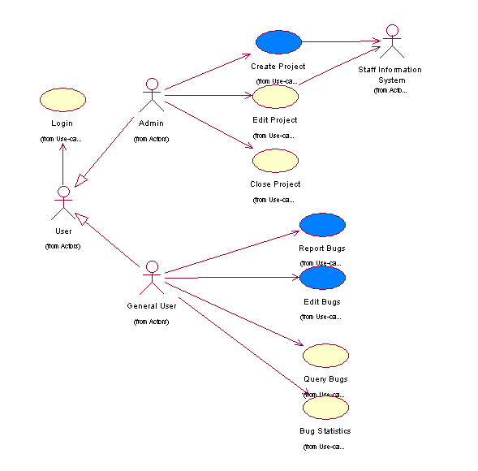

The BTS's architecturally-significant subset of the use cases are colored in blue above. These are described in the following section. These architecture-significant use cases illustrate the key functions of BTS and exercise all major system components. The remaining use-cases can be rapidly developed without changes to the architecture by following the application structure and by reusing the mechanisms described in section 5.

All implemented use cases have an associated Use Case Specification document. References to these documents can be found in the same directory.

4.1Architecturally-Significant Use Cases
The architecturally-significant use cases are those, that “exercise” the most critical parts of the system architecture and demonstrate the core system functionality. In this system they are:
Create Project: This use case allows admin to create a project. When a develop group apply for using this system to track and manage bugs, this use case starts. The admin can set up all the necessary properties for the project.
Basic Scenarios:
- The system requires admin to enter the project basic properties, including the project name, create date.
- Admin enter the basic properties the system requires, and select “next” button.
- The system shows the page for set up the project roles and authorization. This step can be customized. The system requires the admin to select.
- The admin select the special roles and authorities for the project, and select “next” button.
- The system requires admin to input all the group members’ ID and their role in this project.
- The admin enter all the members’ ID as the system requires.
- The system links to external system—Stuff Information System, and collects all the necessary information for the system, shows it to admin and saves it with the information of member’s role.

Report Bugs: This use case is to describe the workflow of system users who have the authority to report a bug in the test phase.
Basic Scenarios:
- User A choose a report bug page
- Fill some necessary bug information
- Submit the report table
Edit Bugs: This use case allows a User to edit the bug specification either reported by or assigned to himself/herself. Certain user can edit the bug description to modify the bug specification such as status, severity, responsible person and so no.
Basic Scenarios:
- The system validates the role of user to see whether or not this user is authorized to edit the bug specification.
- The system retrieves and displays the content of bug specification.
- User modifies the bug specification wherever he/she wants according to the role this user is undertaken.
Actually, you can reference to the sequence diagrams and collaboration diagrams of these very important use cases in the analysis model.

5Logical View
This section describes the architecturally significant parts of the design model, such as its decomposition into subsystems and packages. It describes the logical structure of the system. It starts from the overview of the architecture and then presents its key structure, behavioral elements and mechanisms.

5.1Overview
There are three dominant structures in the application design model:
- Logical decomposition of the system into three layers.
- The structure of the use case realizations derived from model templates of architectural mechanisms.
- The design mechanisms package contains the a pre-designed solution to a common problem.
The high-level diagram of above is showed below:

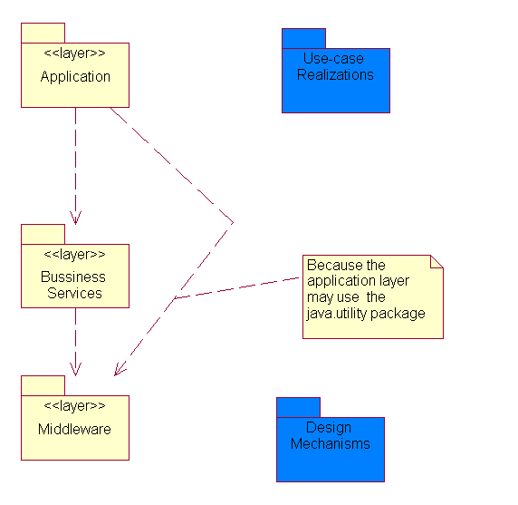

The three layers are introduced below:
- Middleware: The java and javax component we need to use in this system.
- Bussiness Services: Including business components and one common elements and services component. The components in this layer have a high reusability.
- Application: This layer aim at special logic. It has a close relation to the presentation logic. The boundary classes are contained in this layer.

5.2Design Mechanisms
You can see many Mechanisms in the design model. Some of these mechanisms are derived from design patterns. Actually, in our project every member can use these mechanisms to design his whole use case or subsystem. We use mechanisms to provide pre-designed solutions to some common problems that have to be addressed repeatedly in the application and to unify the designs of every part.
In this system, two kinds of mechanisms exist:
- Presentation Request Processing, including
  - FrontController
  - BussinessDelegator
  - ServiceLocator
  - Security
- Business Method and Data access, including
  - Persistency
  - SessionFacade
The two kinds of mechanisms will be addressed below. First a class diagram and a sequence diagram were displayed. Then, I will interpret how the mechanism works and where to use it. At last, why the mechanism should be used and the advantages of the mechanism will be interpreted.

5.2.1Front Controller:
Class diagram and sequence diagram:
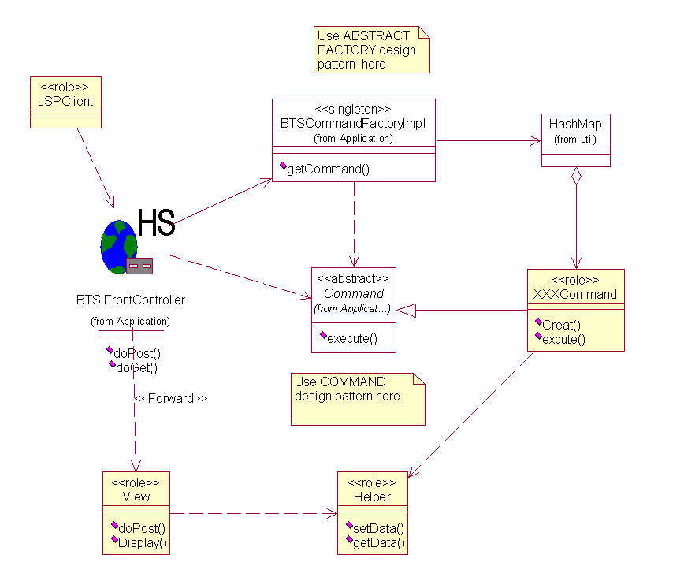

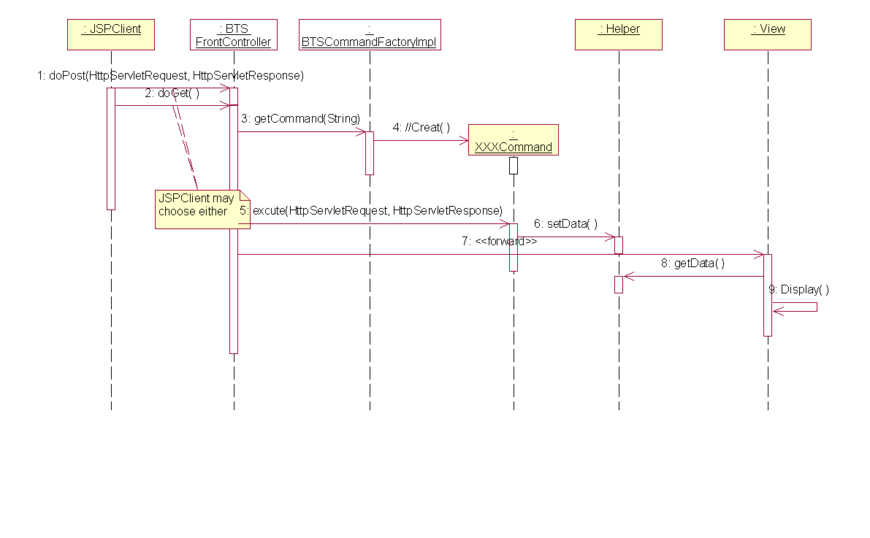

The Roles(The parameters need to be instantiated ) were showed in yellow, the classed showed in white must exist somewhere in the layers architecture as a key element.
How it works:
- The JSPClient send his request (maybe: to get data from database), All the requests from multiple JSPS were send to the BTSFrontController.
- The front controller inspects each request for consistency and verifies if the user needs to be authenticated and authorized.
- The front controller analyzes the request and chooses a command that can finish the task. Ask the Command factory to get a command.
- The command finished the task if required put some data in the helper. Decide which the next page is to display. The command returns the next page to the BTSFrontController.
- The BTSFrontController use the RequestDispatcher(this class is not showed in the diagram, it is a javax component)to dispatch to the next page.
- The view(actually, it is a jsp page) display itself, if needed get some data from the helper.
Key point:
- The front controller is implemented as a HttpServlet.
- The helper implemented as ValueObject(or call it ValueBeans) in our system. It is responsible for holding intermediate model state for use by a view. In J2EE project, it is often held by the HttpRequest or HttpSession Object.
- Command and Object Factory design patterns are used here.
- JSPClient role means a Java Serve Page.
Advantages:
- The Page designer doesn’t need to concern about the logic. He only care about how to present data in valuebeans gracefully.
- A page never needs to know who is the next page if the form is submitted or a URL is clicked. All the requests from users were sent to front controller. So a page never need to know how other page is designed.
- The command pattern decreases coupling. The front controller simply uses command to finish the logic, never need to know other classes.
- Page and command can be developed separately.
- A controller manages business logic processing and request handling. Centralized access to an application means that requests are easily tracked and logged.
- A controller promotes cleaner application partitioning and encourages reuse, as code that is common among components moves into a controller or is managed by a controller.

5.2.2Bussiness Delegator:
Class diagram and sequence diagram:

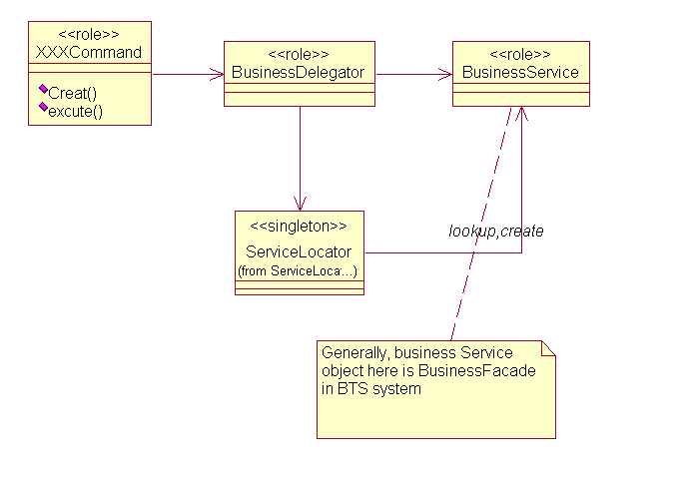

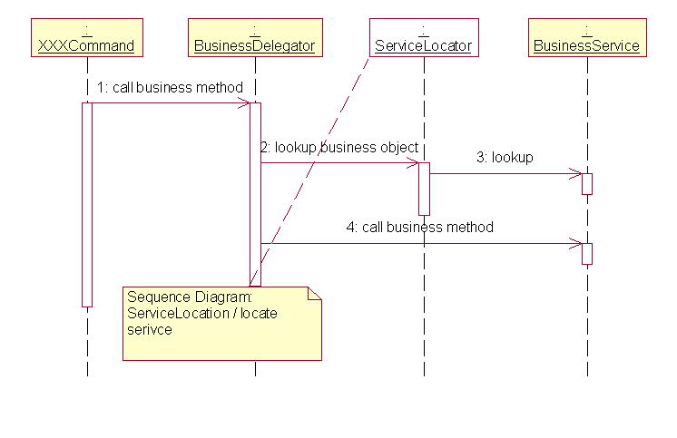

The Roles(The parameters need to be instantiated ) were showed in yellow, the classed showed in white must exist somewhere in the layers architecture as a key element.
How it works:
A client (in most cases it is a command) that requires access to a business service component creates an instance of a session EJB delegate called BusinessDelegator.
Key Point:
Usually the Business Delegate is used with a Session Facade, typically there is an one-to-one relationship between the two.
A Business Delegate uses a component called the Lookup Service (ServiceLocator). The Lookup Service (ServiceLocator) is responsible for hiding the underlying implementation details of the business service lookup code.(The ServiceLocator mechanism will be depicted later.)
Advantages:
- Use a Business Delegate to reduce coupling between presentation-tier clients and business services. The Business Delegate hides the underlying implementation details of the business service, such as lookup and access details of the EJB architecture.
- If necessary, the delegate may cache results and references to remote business services. Caching can significantly improve performance.

5.2.3Service Locator:
Class diagram and sequence diagram:

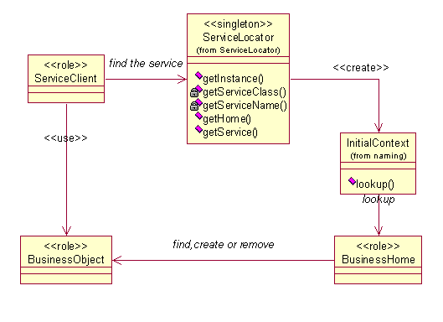

Sequence diagram:
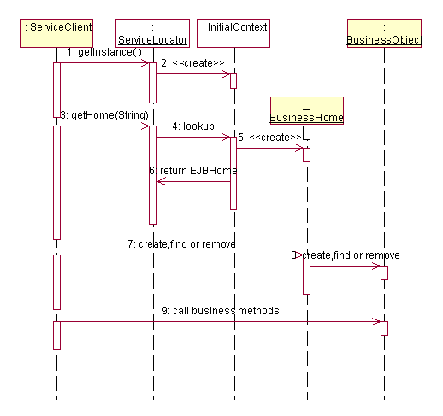

The Roles(The parameters need to be instantiated ) were showed in yellow, the classed showed in white must exist somewhere in the layers architecture as a key element.
How it works:
When the client need to find a EJBhome, it doesn’t do it by itself, that means it doesn’t execute lookup() method and narrow() method(). It simply give a name to the ServiceLocator, the latter return the EJBhome it needed.
Key Point:
In this system, it can be used for Business Delegate to find Session home in this system. It can also used for Session Beans to find Entity Bean home, which will be showed later.
Advantages:
- The Service Locator pattern encapsulates the complexity of this lookup and creation process (described in the problem) and keeps it hidden from the client.
- It provides a very useful and precise interface that all clients can use. The pattern interface ensures that all types of clients in the application uniformly access business objects, in terms of lookup and creation. This uniformity reduces development and maintenance overhead.
- Because clients of enterprise beans are not aware of the EJBHome objects, it's possible to add new EJBHome objects for enterprise beans developed and deployed at a later time without impacting the clients.
- The clients are not involved in JNDI lookup and factory/home object creation. Because the Service Locator performs this work, it can aggregate the network calls required to look up and create business objects.

5.3Security Mechanism:
Class diagram and sequence diagram:
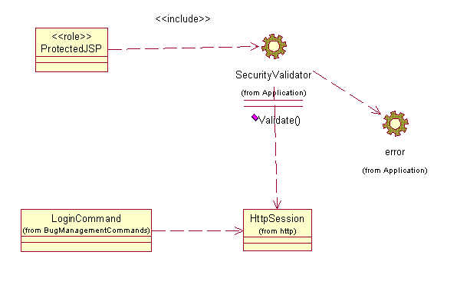

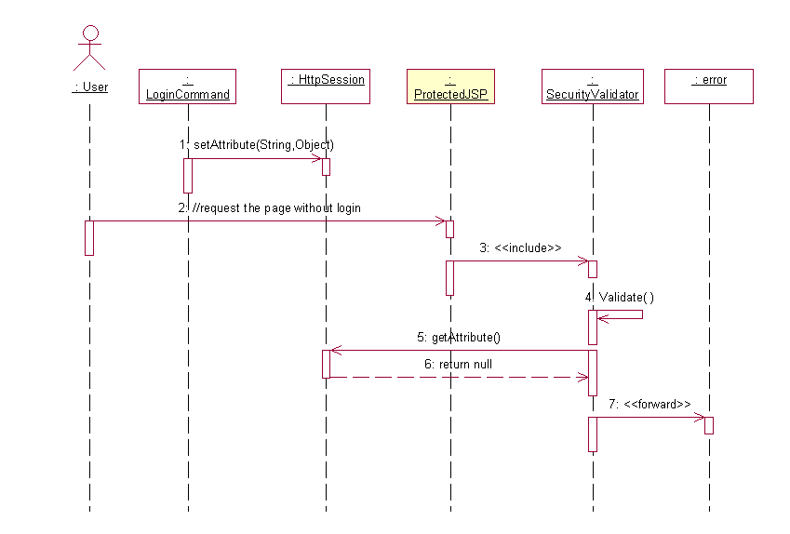

The Roles(The parameters need to be instantiated ) were showed in yellow, the classed showed in white must exist somewhere in the layers architecture as a key element.
How it works:
When the user request the page that is a protected page, the SecutityValidator page which is included by protected pages will validate if the user has login. If not, It forwards to an error page.
Why we use it:
To avoid the users access the resources, which they have no authority to access.
Persistency Mechanism:
Two kinds of Persistency Mechanism exist in this system. One of them is to use CMP. We use CMP to insert， update，delete and do simple queries, using EJB-QL.

Also, we use JDBC directly, when the transaction is not strongly required. Because we think using JDBC directly somewhere reasonably can improve the system performance. Here we only show the class diagram and the sequence diagram, and do not intend to interpret it, since it is very simple and used generally.
RDBMS—JDBC:
Class diagram:

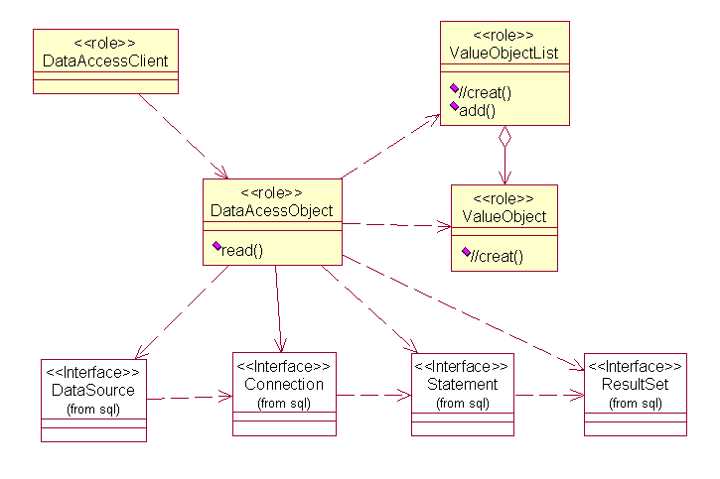

Sequence diagram:
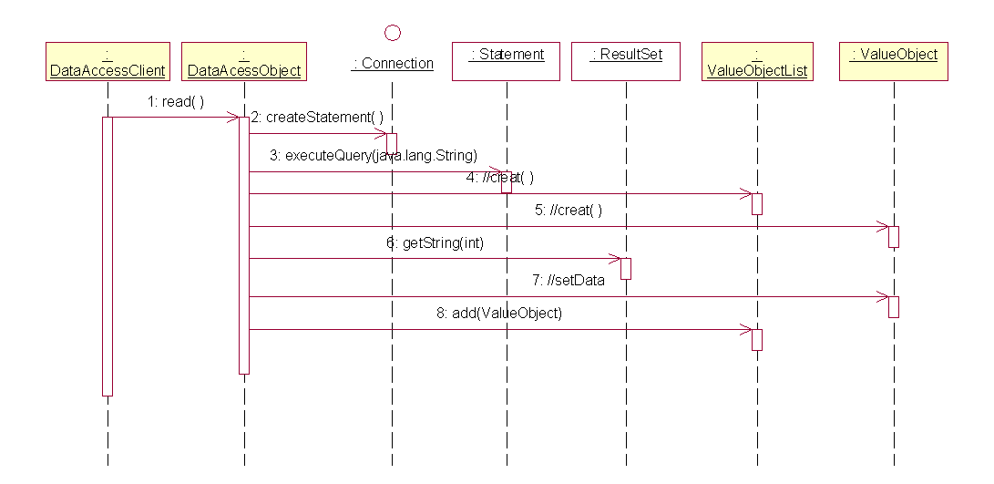

5.3.1SessionFacade:
This Pattern is not addressed in the Design Mechanism package in the Design Model. But every one in our team must use this pattern, when they are designing their own use cases.
How it works:
The mechanism is a “blueprint” for the organization of access to the application server components. The architecture does not allow any presentation layer components to communicate directly with entity EJBs. Hence, the only beans that can be accessed remotely are session EJBs and the mechanism is used for that.
Key Point:
- All business service components are implemented as Session EJBs or have Session EJB façades.
- There is always no one-to-one relationship between SessionFacade and the Entity beans. In this system how SessionFacade Manage its EntityBeans will be depict below as Architecturally-significant Model elements.
- In this system, a BusinessFacade are used by a BusinessDelegator derectly.
Advantages:
- Session Facades can represent a control layer between clients and the business tier, as identified through analysis modeling.
- The underlying interactions between the business components can be very complex. A Session Facade pattern abstracts this complexity and presents the client a simpler interface that is easy to understand and to use.
- Reduces Coupling, Increases Manageability.
- Improves Performance, Reduces Fine-Grained Methods.
- Centralizes Transaction Control.
- Exposes Fewer Remote Interfaces to Clients.

5.4Architecturally-Significant Use Case Realization:
Addressed in the design model, please reference it.

5.5Architecturally-Significant Model Elements:
Architecturally-Significant Packages:
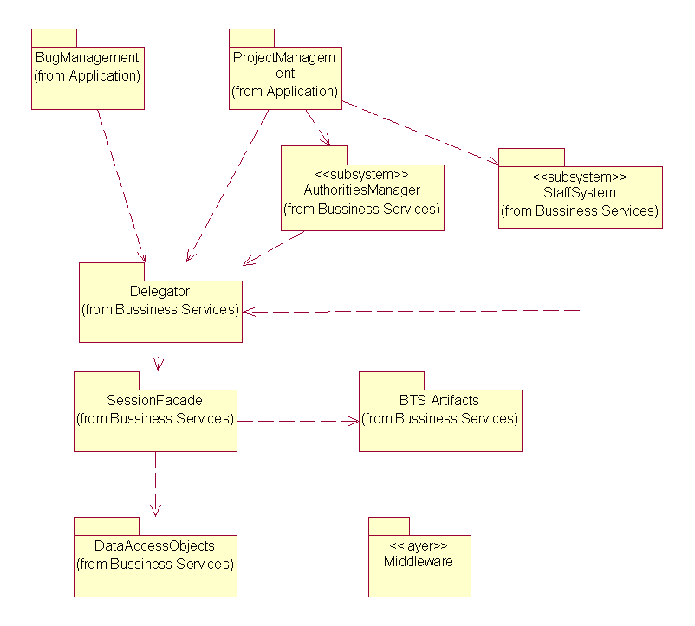

BugManagement: Bug Management related classes , jsps must be put in this package.
ProjectManagement: Project Management related classes, jsps must be put in this package.
AuthoritiesManager Subsystem: Manage Authorities. The client (can be other module of BTS) can use the interface provided by this subsystem to validate whether a operation is permitted. The client can also use the subsystem to creat a role who possess a set of authorities and to add an authority to a special role.
StaffSystem SubSystem:Response for interacting with external staff information system.
Delegator: business delegate classes
SessionFacade: business session façade.
BTS Artifacts: Entity Beans.
DataAccessObject: Data Access Objects, see RDBMS-JDBC mechanism in 5.2.

5.6Architecturally-Significant classes:
Front controller: see front controller mechanism in 5.2.
Abstract Command: see front controller mechanism in 5.2.
Abstract CommandFactory: see front controller mechanism
CommandFactoryImpl: see front controller mechanism.in 5.2
SecurityValidator: see Security mechanism in 5.2.
Errorpage: see Secutiry mechanism in 5.2.
All of the above exist in the Application layer.
ServiceLocator: See serviceLocator Mechanism in 5.2.
Subsystem interfaces: Iauthoritiesmanager and Istaffinfosystem.
There are two Bussiness Delegators, two SessionFacades, for Artitecturally-Significant Entity Beans in this system. The class diagram is showed.
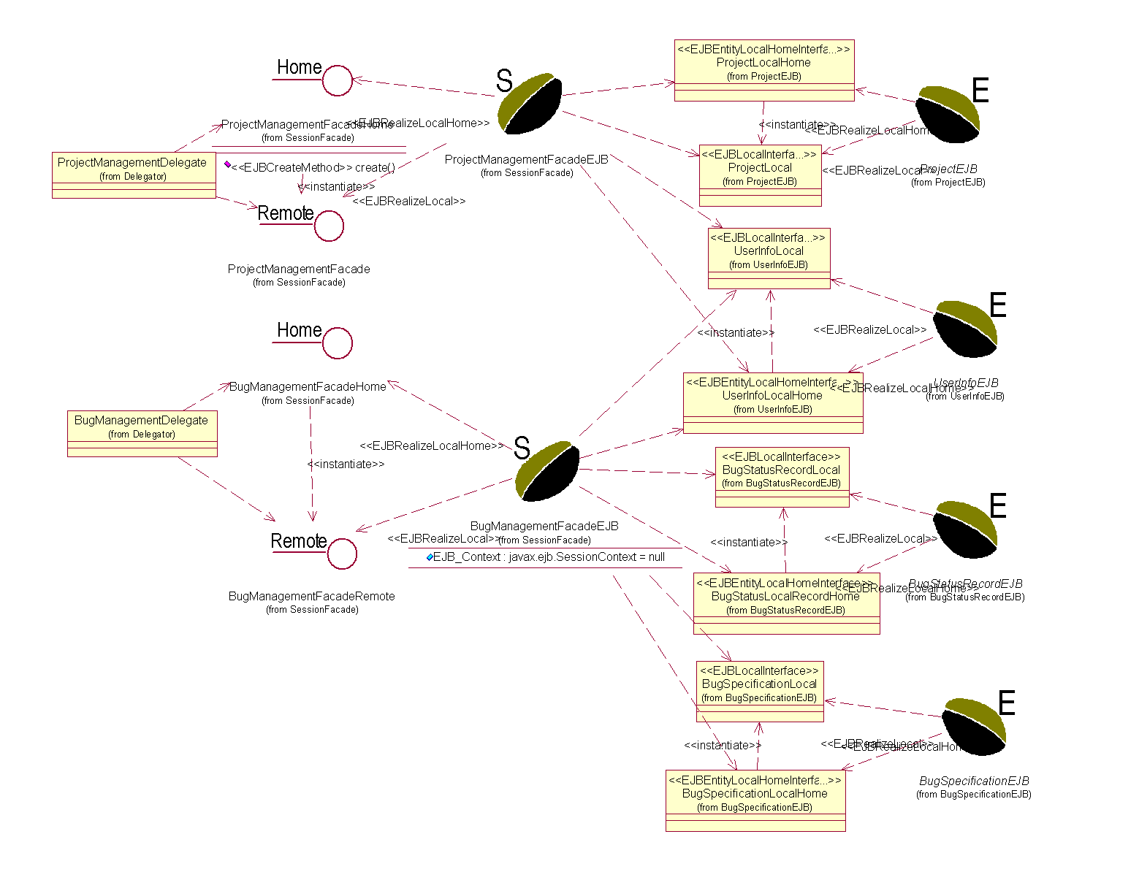

6Process View
The process view of a system shows the assignment of active classes (classes that must run in their independent threads of control) to the operating systems processes and threads. In the case of J2EE deployment platform, the operating system resources are “hidden” underneath the container services. In other words, the infrastructure manages the operating system resources. In particular, the containers are placed in operating system processes or JVMs and the containers in turn manage thread-pools and assign the threads to active objects.
Since the thread are managed by container automatically, we didn’t give a process view in our model.

7Deployment View
The deployment view of a system shows the physical nodes on which the system executes and the assignment of the system processed to the nodes. The BTS reference application can be deployed on different hardware configurations. It can be deployed on a single NT workstation. The diagram below shows the most typical deployment configuration used by the development team.
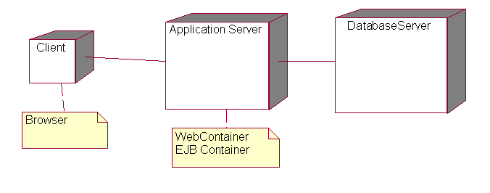

8Implementation View
Organized by IDE , in this system, we use WSAD. So we do not intend to address it.

9Size and Performance
- The chosen software architecture supports the key sizing and timing requirements:
- The system shall support up to 2000 simultaneous users against the central database at any given time, and up to 500 simultaneous users against the local servers at any one time.
- The system shall provide access to the legacy course catalog database with no more than a 10 second latency.
- The system must be able to complete 80% of all transactions within 2 minutes.
- The client portion shall require less than 20 MB disk space and 32 MB RAM.

10Systems Size
The Online Auction application’s size is described with the following items:
- Labor months: 7.5
- Business components: 2
- Dependencies on external components: 1
- Lines of Java code: approximately 5,000
- Java source files: 150
- JSP files: 19
- Implemented use cases: 8

